Length Conditions

Definition
# Source: AI Source: Provided by: [Data Path: Persons Table -> ID Column: 1, Name_En Column: Motasem Essam] -> From: [ChatGPT] on [7/25/2026]
Length Conditions are geometric conditions that specify, compare, or constrain the lengths of geometric objects such as line segments, sides, diagonals, radii, diameters, altitudes, medians, or other measurable segments.
A length condition tells us how long a geometric object is, how its length relates to another length, or what restrictions its length must satisfy.
$$\boxed{\text{Length Condition}=\text{Requirement involving geometric length}}$$
Examples
$$AB=5$$
means segment $\overset{‾}{AB}$has length 5.
$$AB=CD$$
means two segments have equal lengths.
$$AB>CD$$
means $\overset{‾}{AB}$is longer than $\overset{‾}{CD}$.
$$AB=2CD$$
means $AB$is twice the length of $CD$.

Simple Definition
# Source: AI Source: Provided by: [Data Path: Persons Table -> ID Column: 1, Name_En Column: Motasem Essam] -> From: [ChatGPT] on [7/25/2026]
A Length Condition is a requirement that specifies or compares the length of one or more geometric objects.
For example:
- “$AB$ has length 10” → $AB=10$
- “$AB$ and $CD$are equal” → $AB=CD$
- “$AB$ is longer than $CD$” → $AB>CD$
- “$AB$ is twice $CD$” → $AB=2CD$

Main Types of Length Conditions
# Source: AI Source: Provided by: [Data Path: Persons Table -> ID Column: 1, Name_En Column: Motasem Essam] -> From: [ChatGPT] on [7/25/2026]
A practical classification is:
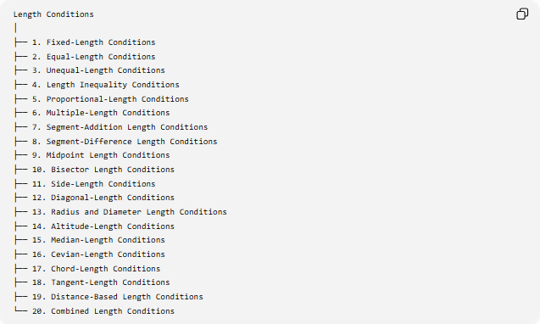
Length Conditions
│
├── 1. Fixed-Length Conditions
├── 2. Equal-Length Conditions
├── 3. Unequal-Length Conditions
├── 4. Length Inequality Conditions
├── 5. Proportional-Length Conditions
├── 6. Multiple-Length Conditions
├── 7. Segment-Addition Length Conditions
├── 8. Segment-Difference Length Conditions
├── 9. Midpoint Length Conditions
├── 10. Bisector Length Conditions
├── 11. Side-Length Conditions
├── 12. Diagonal-Length Conditions
├── 13. Radius and Diameter Length Conditions
├── 14. Altitude-Length Conditions
├── 15. Median-Length Conditions
├── 16. Cevian-Length Conditions
├── 17. Chord-Length Conditions
├── 18. Tangent-Length Conditions
├── 19. Distance-Based Length Conditions
└── 20. Combined Length Conditions
This is a practical/descriptive classification. These categories can overlap.

1. Fixed-Length Conditions
# Source: AI Source: Provided by: [Data Path: Persons Table -> ID Column: 1, Name_En Column: Motasem Essam] -> From: [ChatGPT] on [7/25/2026]
Definition
A Fixed-Length Condition specifies that a geometric segment or object has a particular constant length.
$$\boxed{AB=L}$$
where $L$is a fixed value.
Example
If:
$$AB=8\text{ cm}$$
then segment $AB$must always have length 8 cm.
Another Example
Construct a triangle satisfying:
$$AB=6, AC=5, BC=7.$$
All three side lengths are fixed.
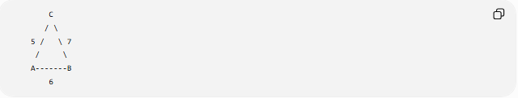
C
/ \
5 / \ 7
/ \
A-------B
6
Important Idea
A fixed-length condition often produces a circle locus when one endpoint is fixed.
If:
$$PA=5$$
then $P$must lie on the circle centered at $A$with radius 5.
$$\boxed{PA=5→\text{Circle centered at }A}$$

2. Equal-Length Conditions
# Source: AI Source: Provided by: [Data Path: Persons Table -> ID Column: 1, Name_En Column: Motasem Essam] -> From: [ChatGPT] on [7/25/2026]
Definition
An Equal-Length Condition requires two or more geometric segments to have the same length.
$$\boxed{AB=CD}$$
Example
If:
$$AB=7, CD=7,$$
then:
$$AB=CD.$$
In an Isosceles Triangle
If:
$$AB=AC,$$
then triangle $ABC$has two equal sides.
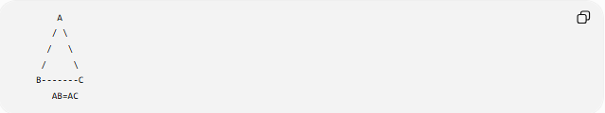
A
/ \
/ \
/ \
B-------C
AB=AC
This is an important length condition because it leads to an angle relationship:
$$AB=AC⇒∠B=∠C.$$
Locus Example
If:
$$PA=PB,$$
then $P$lies on the perpendicular bisector of $\overset{‾}{AB}$.
$$\boxed{PA=PB→\text{Perpendicular Bisector of }AB}$$

3. Unequal-Length Conditions
# Source: AI Source: Provided by: [Data Path: Persons Table -> ID Column: 1, Name_En Column: Motasem Essam] -> From: [ChatGPT] on [7/25/2026]
Definition
An Unequal-Length Condition states that two lengths are not equal.
$$\boxed{AB≠CD}$$
This can be divided into:
$$AB<CD$$
or
$$AB>CD.$$
Therefore:
$$\boxed{AB≠CD ⟺ AB<CD\text{ or }AB>CD}$$
Example
If:
$$AB=5, CD=8,$$
then:
$$AB≠CD.$$

4. Length Inequality Conditions
# Source: AI Source: Provided by: [Data Path: Persons Table -> ID Column: 1, Name_En Column: Motasem Essam] -> From: [ChatGPT] on [7/25/2026]
Definition
A Length Inequality Condition compares lengths using $<,>,≤,≥$.
Examples:
$$AB>CD \\ AB<CD \\ AB≥CD \\ AB≤CD.$$
Example
If:
$$AB=12, CD=9,$$
then:
$$AB>CD.$$
Triangle Example
For a triangle with side lengths $a,b,c$:
$$a+b>c.$$
This is the Triangle Inequality.

5. Proportional-Length Conditions
# Source: AI Source: Provided by: [Data Path: Persons Table -> ID Column: 1, Name_En Column: Motasem Essam] -> From: [ChatGPT] on [7/25/2026]
Definition
A Proportional-Length Condition specifies a fixed ratio between two or more lengths.
$$\boxed{\frac{AB}{CD}=k}$$
where $k$is a constant.
Example
If:
$$AB=2CD,$$
then:
$$\frac{AB}{CD}=2.$$
If $CD=5$:
$$AB=10.$$
Similar Triangles
For similar triangles:
$$\frac{AB}{DE}=\frac{BC}{EF}=\frac{AC}{DF}.$$
The corresponding lengths are proportional.

6. Multiple-Length Conditions
# Source: AI Source: Provided by: [Data Path: Persons Table -> ID Column: 1, Name_En Column: Motasem Essam] -> From: [ChatGPT] on [7/25/2026]
Definition
A Multiple-Length Condition specifies several length requirements simultaneously.
Example
A triangle may satisfy:
$$AB=6, \\ BC=8, \\ CA=10.$$
Together:
$$\boxed{AB=6, BC=8, CA=10}$$
form a system of length conditions.
These lengths produce a $6$-$8$-$10$ right triangle because:
$$6^{2}+8^{2}={10}^{2}.$$

7. Segment-Addition Length Conditions
# Source: AI Source: Provided by: [Data Path: Persons Table -> ID Column: 1, Name_En Column: Motasem Essam] -> From: [ChatGPT] on [7/25/2026]
Definition
A Segment-Addition Length Condition expresses the length of a larger segment as the sum of smaller segments.
If $B$lies between $A$and $C$:
$$\boxed{AC=AB+BC}$$
This is the Segment Addition Postulate.
Example
If:
$$AB=4, BC=7,$$
then:
$$AC=4+7=11.$$
A----4----B-------7-------C
|---------- 11 ----------|
Reverse Use
If:
$$AC=15, AB=6,$$
then:
$$BC=AC-AB=15-6=9.$$

8. Segment-Difference Length Conditions
# Source: AI Source: Provided by: [Data Path: Persons Table -> ID Column: 1, Name_En Column: Motasem Essam] -> From: [ChatGPT] on [7/25/2026]
Definition
A Segment-Difference Condition determines a smaller segment by subtracting one length from another.
If $B$lies between $A$and $C$:
$$\boxed{BC=AC-AB}$$
Example
Given:
$$AC=20, AB=12,$$
then:
$$BC=20-12=8.$$
This is essentially the reverse use of segment addition.

9. Midpoint Length Conditions
# Source: AI Source: Provided by: [Data Path: Persons Table -> ID Column: 1, Name_En Column: Motasem Essam] -> From: [ChatGPT] on [7/25/2026]
Definition
A Midpoint Length Condition occurs when a point divides a segment into two equal parts.
If $M$is the midpoint of $\overset{‾}{AB}$:
$$\boxed{AM=MB}$$
and:
$$\boxed{AB=2AM=2MB}$$
Example
If:
$$AB=14,$$
then:
$$AM=MB=7.$$
A-------M-------B
7 7
Important Relationship
$$M\text{ midpoint of }AB⇒AM=MB.$$
But a midpoint condition also requires $M$to lie on the segment $\overset{‾}{AB}$.

10. Bisector Length Conditions
# Source: AI Source: Provided by: [Data Path: Persons Table -> ID Column: 1, Name_En Column: Motasem Essam] -> From: [ChatGPT] on [7/25/2026]
A segment bisector divides a segment into two equal lengths.
If line $l$bisects $\overset{‾}{AB}$at $M$:
$$\boxed{AM=MB}$$
Example
If:
$$AB=18,$$
then the bisector point satisfies:
$$AM=MB=9.$$
Important Distinction
A segment bisector concerns length:
$$AM=MB.$$
An angle bisector concerns angle measures:
$$∠BAD=∠DAC.$$

11. Side-Length Conditions
# Source: AI Source: Provided by: [Data Path: Persons Table -> ID Column: 1, Name_En Column: Motasem Essam] -> From: [ChatGPT] on [7/25/2026]
Definition
A Side-Length Condition specifies relationships among the side lengths of a polygon.
Triangle
For triangle $ABC$:
$$AB=c, BC=a, CA=b.$$
Example
$$AB=5, BC=7, CA=8.$$
The triangle's side lengths are:
$$5, 7, 8.$$
Isosceles Triangle
$$AB=AC.$$
Equilateral Triangle
$$AB=BC=CA.$$
Therefore:
$$\boxed{a=b=c}$$

12. Diagonal-Length Conditions
# Source: AI Source: Provided by: [Data Path: Persons Table -> ID Column: 1, Name_En Column: Motasem Essam] -> From: [ChatGPT] on [7/25/2026]
Definition
A Diagonal-Length Condition specifies the length or relationship of diagonals of a polygon.
Example
For quadrilateral $ABCD$:
$$AC=10.$$
This specifies the diagonal $AC$.
Rectangle
A rectangle has equal diagonals:
$$\boxed{AC=BD}$$
Example
If:
$$AC=15,$$
then:
$$BD=15.$$
Square
A square with side length $s$has diagonal:
$$\boxed{d=s\sqrt{2}}$$
If:
$$s=5,$$
then:
$$d=5\sqrt{2}.$$

13. Radius and Diameter Length Conditions
# Source: AI Source: Provided by: [Data Path: Persons Table -> ID Column: 1, Name_En Column: Motasem Essam] -> From: [ChatGPT] on [7/25/2026]
Definition
These conditions specify or relate the radius and diameter of a circle.
The fundamental relationship is:
$$\boxed{d=2r}$$
and:
$$\boxed{r=\frac{d}{2}}.$$
Example
If:
$$r=6,$$
then:
$$d=12.$$
If:
$$d=20,$$
then:
$$r=10.$$
Circle Circumference
$$C=2πr$$
or:
$$C=πd.$$
Circle Area
$$A=πr^{2}.$$
Thus, a radius condition can determine several other geometric quantities.

14. Altitude-Length Conditions
# Source: AI Source: Provided by: [Data Path: Persons Table -> ID Column: 1, Name_En Column: Motasem Essam] -> From: [ChatGPT] on [7/25/2026]
Definition
An Altitude-Length Condition specifies the length of an altitude of a polygon, especially a triangle.
For triangle $ABC$, if:
$$AD⊥BC,$$
then $AD$is an altitude.
A length condition could be:
$$\boxed{AD=8}.$$
Area Connection
The triangle's area is:
$$\boxed{K=\frac{1}{2}bh}$$
where $h=AD$.
Example
If:
$$BC=12, AD=5,$$
then:
$$K=\frac{1}{2}\left(12\right)\left(5\right)=30.$$
So a length condition on an altitude can create an area condition.

15. Median-Length Conditions
# Source: AI Source: Provided by: [Data Path: Persons Table -> ID Column: 1, Name_En Column: Motasem Essam] -> From: [ChatGPT] on [7/25/2026]
Definition
A Median-Length Condition specifies the length of a median of a triangle.
If $M$is the midpoint of $BC$:
$$BM=MC$$
and $AM$is a median.
Example
If:
$$AM=7,$$
then the median has length 7.
Using Apollonius' Theorem:
$$\boxed{AM^{2}=\frac{2AB^{2}+2AC^{2}-BC^{2}}{4}}$$
Example
Let:
$$AB=5, AC=7, BC=8.$$
Then:
$$AM^{2}=\frac{2\left(5^{2}\right)+2\left(7^{2}\right)-8^{2}}{4} \\ =\frac{50+98-64}{4} \\ =\frac{84}{4}=21.$$
Therefore:
$$\boxed{AM=\sqrt{21}}.$$

16. Cevian-Length Conditions
# Source: AI Source: Provided by: [Data Path: Persons Table -> ID Column: 1, Name_En Column: Motasem Essam] -> From: [ChatGPT] on [7/25/2026]
Definition
A Cevian-Length Condition specifies the length of a segment drawn from a vertex of a triangle to the opposite side or its extension.
Examples include:
- median
- angle bisector
- altitude
- general cevian.
Example
If $AD$is a cevian:
$$\boxed{AD=9}$$
is a cevian-length condition.
Stewart's Theorem
For:
$$BD=m, DC=n, BC=a,$$
and:
$$AB=c, AC=b, AD=d,$$
Stewart's Theorem gives:
$$\boxed{b^{2}m+c^{2}n=a\left(d^{2}+mn\right)}.$$
This allows a cevian length to be calculated from other length conditions.

17. Chord-Length Conditions
# Source: AI Source: Provided by: [Data Path: Persons Table -> ID Column: 1, Name_En Column: Motasem Essam] -> From: [ChatGPT] on [7/25/2026]
Definition
A Chord-Length Condition specifies or compares the length of a chord of a circle.
For a circle of radius $R$, a chord subtending central angle $θ$has length:
$$\boxed{c=2R\sin{\frac{θ}{2}}}.$$
Example
If:
$$R=10, θ={60}^{∘},$$
then:
$$c=2\left(10\right)\sin{{30}^{∘}} \\ c=20\left(\frac{1}{2}\right) \\ \boxed{c=10}.$$
Maximum Chord
The longest possible chord is the diameter:
$$\boxed{c≤2R}.$$
Equality occurs when the chord is a diameter.

18. Tangent-Length Conditions
# Source: AI Source: Provided by: [Data Path: Persons Table -> ID Column: 1, Name_En Column: Motasem Essam] -> From: [ChatGPT] on [7/25/2026]
Definition
A Tangent-Length Condition specifies the length of a tangent segment from an external point to a circle.
If $PT$is tangent to a circle with center $O$:
$$OT⊥PT.$$
Therefore:
$$\boxed{PT=\sqrt{OP^{2}-r^{2}}}.$$
Example
If:
$$OP=13, r=5,$$
then:
$$PT=\sqrt{{13}^{2}-5^{2}} \\ =\sqrt{169-25} \\ =\sqrt{144} \\ \boxed{PT=12}.$$

19. Distance-Based Length Conditions
# Source: AI Source: Provided by: [Data Path: Persons Table -> ID Column: 1, Name_En Column: Motasem Essam] -> From: [ChatGPT] on [7/25/2026]
Definition
A Distance-Based Length Condition involves the distance between geometric objects.
Examples:
$$PA=5 \\ AB=10 \\ d\left(P , l\right)=4.$$
Although distance conditions are broader than ordinary segment-length conditions, many distance conditions are expressed through lengths.
Example
A point $P$is required to be 5 units from point $A$:
$$PA=5.$$
The locus is:
$$\boxed{\text{circle centered at }A\text{ with radius }5}.$$

20. Combined Length Conditions
# Source: AI Source: Provided by: [Data Path: Persons Table -> ID Column: 1, Name_En Column: Motasem Essam] -> From: [ChatGPT] on [7/25/2026]
Definition
A Combined Length Condition contains two or more length relationships that must hold simultaneously.
Example
Suppose point $P$must satisfy:
$$PA=5$$
and:
$$PB=4.$$
Then:
$$P∈C\left(A , 5\right)$$
and:
$$P∈C\left(B , 4\right).$$
Therefore:
$$\boxed{P∈C\left(A , 5\right)∩C\left(B , 4\right)}$$
The solution consists of the common intersection point(s) of the two circles.
Another Example
A triangle satisfies:
$$AB=AC$$
and:
$$BC=10.$$
The first condition makes the triangle isosceles, while the second fixes its base length.

Length Conditions and Loci
# Source: AI Source: Provided by: [Data Path: Persons Table -> ID Column: 1, Name_En Column: Motasem Essam] -> From: [ChatGPT] on [7/25/2026]
Length conditions frequently generate geometric loci.
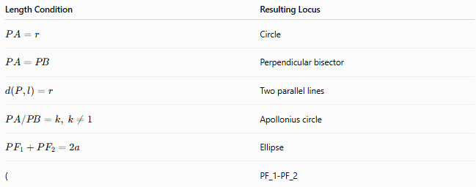
Length Condition | Resulting Locus
$$PA=r$$ | Circle
$$PA=PB$$ | Perpendicular bisector
$$d\left(P , l\right)=r$$ | Two parallel lines
$$PA/PB=k, k≠1$$ | Apollonius circle
$$PF_{1}+PF_{2}=2a$$ | Ellipse
( | PF_1-PF_2
This gives an important relationship:
$$\boxed{\text{Length Condition}→\text{Geometric Locus}}$$
For example:
$$PA=5$$
becomes:
$$\boxed{\text{Circle centered at }A\text{ with radius }5}.$$

Length Conditions in Geometric Figures
# Source: AI Source: Provided by: [Data Path: Persons Table -> ID Column: 1, Name_En Column: Motasem Essam] -> From: [ChatGPT] on [7/25/2026]
Length conditions can define important classes of figures.
Triangle
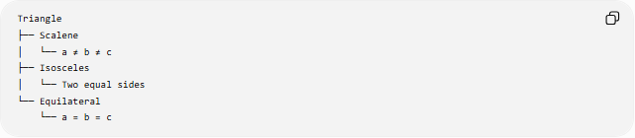
Triangle
├── Scalene
│ └── a ≠ b ≠ c
├── Isosceles
│ └── Two equal sides
└── Equilateral
└── a = b = c
Quadrilateral
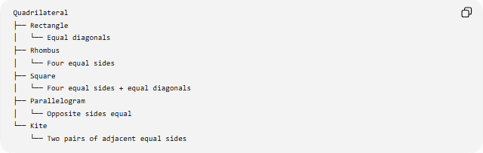
Quadrilateral
├── Rectangle
│ └── Equal diagonals
├── Rhombus
│ └── Four equal sides
├── Square
│ └── Four equal sides + equal diagonals
├── Parallelogram
│ └── Opposite sides equal
└── Kite
└── Two pairs of adjacent equal sides
These are examples of length conditions contributing to geometric classification.

Algebraic Representation of Length Conditions
# Source: AI Source: Provided by: [Data Path: Persons Table -> ID Column: 1, Name_En Column: Motasem Essam] -> From: [ChatGPT] on [7/25/2026]
Geometric lengths can often be represented algebraically.
For example:
$$AB=x+3$$
and:
$$CD=2x-1.$$
If:
$$AB=CD,$$
then:
$$x+3=2x-1.$$
Therefore:
$$x=4.$$
The geometric condition has been converted into an algebraic equation.

Coordinate Geometry and Length Conditions
# Source: AI Source: Provided by: [Data Path: Persons Table -> ID Column: 1, Name_En Column: Motasem Essam] -> From: [ChatGPT] on [7/25/2026]
For points:
$$A\left(x_{1} , y_{1}\right), B\left(x_{2} , y_{2}\right),$$
the distance is:
$$\boxed{AB=\sqrt{{\left(x_{2}-x_{1}\right)}^{2}+{\left(y_{2}-y_{1}\right)}^{2}}}$$
Example
Let:
$$A=\left(1 , 2\right), B=\left(7 , 10\right).$$
Then:
$$AB=\sqrt{{\left(7-1\right)}^{2}+{\left(10-2\right)}^{2}} \\ =\sqrt{36+64} \\ =\boxed{10}.$$
Therefore, the length condition $AB=10$is satisfied.

Important Relationships Between Length Conditions
# Source: AI Source: Provided by: [Data Path: Persons Table -> ID Column: 1, Name_En Column: Motasem Essam] -> From: [ChatGPT] on [7/25/2026]
Length conditions can lead to other geometric conditions.
Equal sides
$$AB=AC$$
leads to:
$$∠B=∠C.$$
Equal diagonals in a rectangle
$$AC=BD.$$
Radius and diameter
$$d=2r.$$
Side and diagonal of a square
$$d=s\sqrt{2}.$$
Base and height
$$A=\frac{1}{2}bh.$$
Thus:
$$\boxed{\text{Length Condition}→\text{Other Geometric Property}}$$

Length Conditions vs Distance Conditions
# Source: AI Source: Provided by: [Data Path: Persons Table -> ID Column: 1, Name_En Column: Motasem Essam] -> From: [ChatGPT] on [7/25/2026]
These concepts overlap but are not exactly identical.
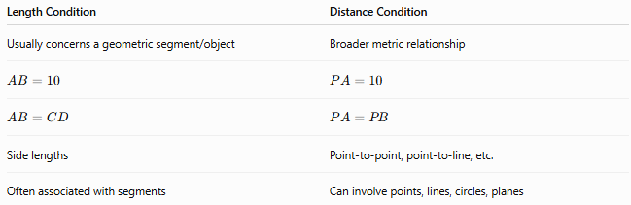
Length Condition | Distance Condition
Usually concerns a geometric segment/object | Broader metric relationship
$$AB=10$$ | $$PA=10$$
$$AB=CD$$ | $$PA=PB$$
Side lengths | Point-to-point, point-to-line, etc.
Often associated with segments | Can involve points, lines, circles, planes
For example:
$$AB=10$$
is naturally described as a length condition.
But:
$$d\left(P , l\right)=10$$
is more naturally described as a distance condition.

Classification Summary
# Source: AI Source: Provided by: [Data Path: Persons Table -> ID Column: 1, Name_En Column: Motasem Essam] -> From: [ChatGPT] on [7/25/2026]
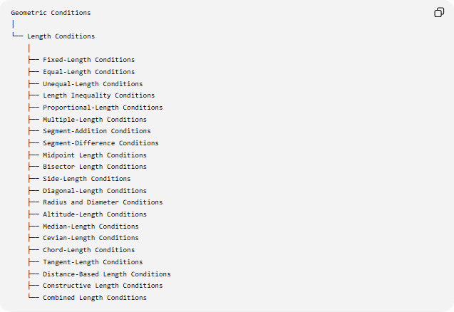
Geometric Conditions
│
└── Length Conditions
│
├── Fixed-Length Conditions
├── Equal-Length Conditions
├── Unequal-Length Conditions
├── Length Inequality Conditions
├── Proportional-Length Conditions
├── Multiple-Length Conditions
├── Segment-Addition Conditions
├── Segment-Difference Conditions
├── Midpoint Length Conditions
├── Bisector Length Conditions
├── Side-Length Conditions
├── Diagonal-Length Conditions
├── Radius and Diameter Conditions
├── Altitude-Length Conditions
├── Median-Length Conditions
├── Cevian-Length Conditions
├── Chord-Length Conditions
├── Tangent-Length Conditions
├── Distance-Based Length Conditions
├── Constructive Length Conditions
└── Combined Length Conditions

Key Formulas
# Source: AI Source: Provided by: [Data Path: Persons Table -> ID Column: 1, Name_En Column: Motasem Essam] -> From: [ChatGPT] on [7/25/2026]
Fixed length
$$\boxed{AB=L}$$
Equal lengths
$$\boxed{AB=CD}$$
Proportional lengths
$$\boxed{\frac{AB}{CD}=k}$$
Segment addition
$$\boxed{AC=AB+BC}$$
Midpoint
$$\boxed{AM=MB=\frac{AB}{2}}$$
Circle
$$\boxed{d=2r}$$
Square diagonal
$$\boxed{d=s\sqrt{2}}$$
Triangle area
$$\boxed{A=\frac{1}{2}bh}$$
Median
$$\boxed{m_{a}=\frac{1}{2}\sqrt{2b^{2}+2c^{2}-a^{2}}}$$
Chord
$$\boxed{c=2R\sin{\frac{θ}{2}}}$$
Tangent
$$\boxed{PT=\sqrt{OP^{2}-r^{2}}}$$
Coordinate distance
$$\boxed{AB=\sqrt{{\left(x_{2}-x_{1}\right)}^{2}+{\left(y_{2}-y_{1}\right)}^{2}}}$$

Key Points
# Source: AI Source: Provided by: [Data Path: Persons Table -> ID Column: 1, Name_En Column: Motasem Essam] -> From: [ChatGPT] on [7/25/2026]
- Length Conditions specify, compare, or constrain geometric lengths.
- They can involve segments, sides, diagonals, radii, diameters, altitudes, medians, cevians, chords, and tangent segments.
- The simplest condition is a fixed length:
$$AB=L.$$
- Equal-length conditions include:
$$AB=CD.$$
- Proportional conditions include:
$$AB=kCD.$$
- Length inequalities include:
$$AB>CD.$$
- Segment addition gives:
$$AC=AB+BC.$$
- Midpoint conditions give:
$$AM=MB.$$
- Length conditions can define special geometric figures such as isosceles triangles, rhombi, rectangles, and squares.
- Length conditions can generate loci:
$$PA=r→\text{circle}, \\ PA=PB→\text{perpendicular bisector}.$$
- Several length conditions can be combined to determine one or more geometric objects.
- A length condition can often be converted into an algebraic equation or coordinate equation.

Conclusion
# Source: AI Source: Provided by: [Data Path: Persons Table -> ID Column: 1, Name_En Column: Motasem Essam] -> From: [ChatGPT] on [7/25/2026]
Length Conditions are one of the fundamental categories of Geometric Conditions. They describe exact lengths, equality, inequality, ratios, division of segments, and relationships among important geometric measurements.
The central idea is:
$$\boxed{\text{Length Condition}→\text{Length Relationship}→\text{Geometric Consequence}}$$
For example:
$$\boxed{PA=5→\text{circle of radius }5} \\ \boxed{PA=PB→\text{perpendicular bisector}} \\ \boxed{AB=AC→\text{isosceles triangle}→∠B=∠C}$$
Thus, length conditions provide a direct connection between measurement, geometric relationships, constructions, loci, and geometric proofs.
Would you like the next section to cover angle conditions or equality conditions?

